DAP

Direct Aid Program

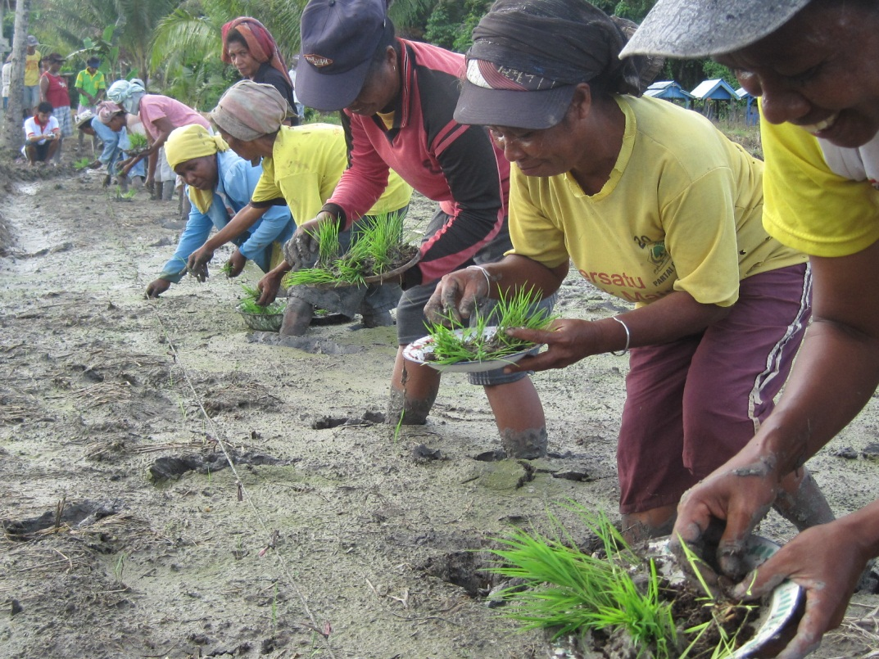

Australian Consulate-General, Makassar
2019 – 2020

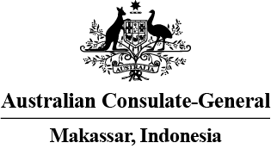
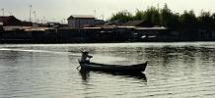
Application Guidelines

What is the Direct Aid Program?
The Australian Consulate-General small grants scheme known as the Direct Aid Program (DAP) is administered under the authority of the Australian Consul-General in Makassar. The primary objective of DAP is to promote sustainable community development initiatives that help communities boost their living standards.
What groups can receive funding from DAP?
DAP funds are made available for community groups and non-government organisations engaged in development activities on a not-for-profit basis in eastern Indonesia (in particular the six provinces of Sulawesi, East and South Kalimantan, the two Maluku provinces and West Papua). All applicants must submit the application form attached, including a complete budget for the project.
Do all proposed projects receive funding?
Applicants should be aware that not all projects submitted to the Consulate-General can be supported as there are limited DAP funds available. As a general rule DAP is unable to assist micro financing/revolving fund programs or grant programs run by other organisations. Unless it is a special case, DAP will not give money for staff salaries, recurring running costs, administrative expenses not directly related to project implementation, and honorariums.
What kinds of projects are most likely to receive funding?
Projects should have a clear objective, show a demonstrated need and be financially transparent. DAP favours projects where recipients have made or are making a significant contribution themselves in labour or administrative costs. Projects should be completed in a time frame of up to 12 months and should have a workable implementation plan. The Consulate-General anticipates that most projects will fall within the range of IDR 50,000,000 – IDR 150,000,000; however, proposals above and below these amounts will also be considered.
What happens when a project is approved?
The applicants of all approved projects will be notified by mail and funds will be transferred to the relevant bank account. Approved applicants must provide the Consulate-General with a bank account under the community or organisation’s name. Personal bank accounts will not be accepted. Applications usually take at least two months to process. Once the project has been completed, the community/organisation must provide a brief acquittal report and receipts from the supplier of materials or services to the Australian Consulate-General.
Completed DAP application forms should be forwarded by 23 September 2019, 9 am at the latest to:
The DAP Coordinator
Australian Consulate-General, Makassar
Wisma Kalla Lt. 7
Jalan Dr Sam Ratulangi No. 8
Makassar 90125
Or can be emailed (preferable) to:
dap.makassar@dfat.gov.au
For more information, please contact the Consulate-General:
Email: dap.makassar@dfat.gov.au Tel: +62 411 366 4100
APPLICATION FORM
Applicant Details
Organisation or group name:
Contact person:
Position of contact person:
Postal Address:
Contact telephone number:
Contact hand phone number:
Contact fax number:
Contact email address:
Proposed Project
Name of project:
Type of project:
Location of proposed project: (name of kampung) |  |  | Province:
Project status: | New Project  Existing 
Is an NGO involved in administering the project? |  | Yes  No 
Name of NGO:
NGO contact:
NGO contact telephone number:
NGO contact email address:
NGO postal address:
Name of project supervisors: (must be more than one person)
Has the community group/organisation received DAP funding for any projects before? |  |  |  |  | Yes  No 
If yes, what was the project? |  |  |  | Project complete (DD/MM/YYYY) |  | / /
Project Description
What are the key objectives of the project?
What do you plan to do and what have you done so far?
What are you asking DAP to provide?
Is DAP providing for only part of the project? | Yes  No 
If so, please explain which part of the project and attach evidence of work already completed.
Does your project include building and construction? If so, please provide a building diagram or plan. |  | Yes  No 
Does your project involve the supply of water in any capacity? |  | Yes  No 
If you answered ‘yes’ to the above two questions, we may request further information.

What will the community contribute to the project? What has it already contributed?
If the project will be administered on behalf of a community by an NGO, please describe the relationship between the NGO and the community.
Who and how many people will be the direct beneficiaries of this project?
Are there ways in which other people in the area will benefit indirectly from the project?
Who will be responsible for looking after the project once it is completed? Please insert people’s names and their positions.
Will the project become self-supporting? If so, how will the project be sustained on an ongoing basis once DAP funds are complete?

What is the estimated length of time to complete the project?
Detail the estimated project costs.
Please indicate amounts in Australian dollars or Indonesian rupiah only.
Please indicate which costs will be met by DAP funds. This must be completed.
Water Projects
If your project involves the supply of water in any capacity, please complete the following section.
Has the water source been tested and verified as not being contaminated?
Will the project affect any down-stream users or impact on the down-stream environment?
Building and Construction Projects
Please provide a written undertaking that the building and construction materials will not contain asbestos, and that construction will comply with the Indonesian building code and with Indonesian labour laws and regulations.

Project criteria/elements
Please indicate if your project meets each of these criteria.
The project has a clear and measurable outcome | Yes  No 
The project will be finished in less than 12 months | Yes  No 
Your organisation or community is also contributing to the project | Yes  No 
The project will benefit members of the local community | Yes  No 
A completed DAP application form for the project is attached | Yes  No 
A complete budget for the project is attached | Yes  No 
A map of the project is attached (if applicable) | Yes  No 
For projects which involve building or construction: a building diagram or plan is attached | Yes  No 
Applicant(s) contact information | Yes  No 

How did you find out about the Direct Aid Program (DAP)?
Declaration
This declaration must be signed by ALL project applicants before the application will be considered.
This application for DAP funding is submitted to undertake the project as detailed above. The project is made to assist the community identified in this application in the way described above. The project is not for personal benefit. I will abide by Indonesian law and regulations. I understand by signing that I am agreeing to the conditions outlined in the guidelines and I am liable to prosecution under Indonesian law, should I make a false declaration.
Applicant signature: Date: / /
Applicant Name: DD/MM/YYYY
Position:

Applicant signature: Date: / /
Applicant Name: DD/MM/YYYY
Position:

Applicant signature: Date: / /
Applicant Name: DD/MM/YYYY
Position:

